Sponsored by
Hampshire Food Festival
1st - 31st July 2018

All you need to know about booking entries into the 2018 Hampshire Food Festival
The Hampshire Food Festival (HFF) is an opportunity to raise the profile of your business. Involving over 60 food and farming events across the county, it celebrates Hampshire’s local food and drink scene. In 2017, the festival attracted an estimated 150,000 visitors and achieved over £4million in visitor spending. The 2017 festival was recognised at the Beautiful South Awards with a bronze award.

To get involved, you can choose to enter 1 or more events, offers, and/or stay/dine promotions. All entries must include an element of local produce.

Programme (new larger format)
All entries will be listed in the festival programme. 25,000 copies will be distributed to key footfall locations throughout the region.

For an event entry, you can choose a free basic listing or upgrade to an enhanced listing to help your event and business stand out with an image and additional wording. This year, the programme of events will be in week to view format, in date order.

Social Media
Entries will be promoted via our social media channels. We have 15K followers on Twitter, 1.6K on Facebook and 1.1k on Instagram. We will be boosting a number of posts on Facebook to further raise awareness.

Consumer newsletter
We have 13,000 subscribers to our monthly newsletter. The Hampshire Food Festival will be heavily promoted on here from May and throughout July.

Website
All events are listed on our website shortly after they are submitted to us. During June and July 2017 our website had over 84,000 visits and over 33,000 of these were unique visits. Your listing will include a link to your website when relevant.

Press
The festival is promoted to local and national press and has previously been featured in Jamie Magazine, Delicious magazine, and Food and Travel Magazine. We will be hosting a press day in May and one later on for press and VIPs. The earlier you let us know about your event/s, the more chance we have of engaging national press.

Be creative
We LOVE creative and innovative food festival event ideas to keep the festival fresh and exciting. All that we ask is that the event involves local produce. The most successful events are the ones that offer something different or a unique opportunity to do or experience something. If you have an idea but need a venue, speak to us. If you have a venue but need to get producers on board, speak to us. We are here to connect local businesses so we can make the 2018 festival the best one yet!

Programme entry options

* = Community Interest Company or Charity Organisation
Non-Hampshire Fare members = see prices in table overleaf

Event (examples below)
Basic listing
For Hampshire Fare members and *: First event/date: FREE; Additional events/dates: £30 each
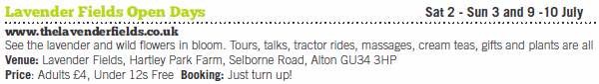

Enhanced listing
For Hampshire Fare members and *: £125 each
An added benefit of an Enhanced Listing is priority exposure via social media, website and PR activity.
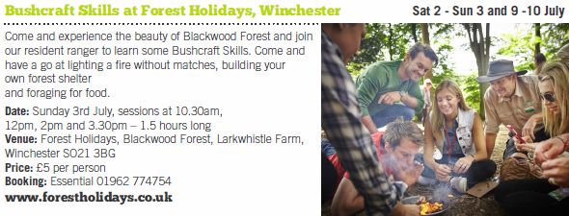

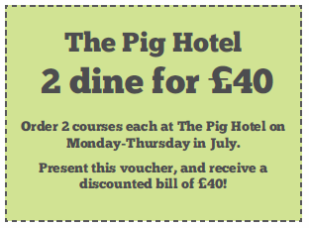
Offer (example right)
For Hampshire Fare members only: £50 each

Stay/Dine (example below)
For Hampshire Fare members and *: £125 each
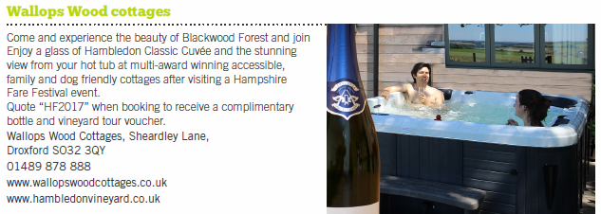

Confirm your entries

Please indicate your entry quantity and cost totals in the table below:

 | Entry options | Quantity | Price (exc. VAT) | Price (inc. VAT) | Total cost (inc. VAT)
Hampshire Fare member or * | First basic event/ date | (1 max) | FREE | FREE
 | Additional basic events/dates |  | £30 | £36
 | Enhanced event listing with image |  | £125 | £150
 | Offer (Hampshire Fare members only) |  | £50 | £60
 | Stay/Dine listing with image |  | £125 | £150
 | Full page advert (specs TBC) |  | £500 | £600
Non- Hampshire Fare member | Basic event listing |  | £75 | £90
 | Enhanced event listing with image |  | £195 | £234
 | Stay/Dine listing with image |  | £200 | £240
 | Full page advert (specs TBC) |  | £950 | £1140
 | Totals |  | N/A | N/A

Entry forms

Please complete the relevant entry forms below:

If you’re entering multiple events, offers or stay/dine promotions, copy and complete the relevant table again.

Event
Event title
Event subheading (max 15 words – we reserve the right to edit this if necessary)
Event date
Event time
Event address
Are tickets required? | Yes/No
Ticket prices | Adult | £ | Child | £
 | OAP | £ | Free? | Yes/No
Booking information | Booking essential? | Yes/No
 | Booking advisable? | Yes/No
 | Just turn up | Yes/No
Is there disabled access? | Yes/No
Is it suitable for children? | Yes/No | If yes, specific age range
For enhanced listing only
Event description (max 40 words – we reserve the right to edit this if necessary)
For enhanced listing only
Any further information you’d like to appear on the online listing?
For enhanced listing only  Image | Please send your image to sarah.medley@hampshirefare.co.uk

Offer
Company name
The offer
Terms and conditions
Valid when?
Stay/Dine
Company name
Description (max 40 words – we reserve the right to edit this if necessary)
Address
Telephone number
Website address
Any further information you’d like to appear on the online listing?
Image | Please send your image to sarah.medley@hampshirefare.co.uk

Your contact details
(Not for publication in the programme)

Data Protection Act 1998.Your details will only be used for Hampshire Food Festival and Hampshire Fare and will not be passed to any other organisation other than those involved in the planning and promotion of this project.

Full name
Company name
Email address
Phone number

Your payment

I have paid by BACS
Account number: 52342360
Sort code: 30-99-71
I have posted a cheque
Hampshire Fare CIC, Rownhams House, Southampton, SO16 8LS
I would like to be emailed an invoice
Please tick if yes

Please return completed forms to:

Email: sarah.medley@hampshirefare.co.uk
Post: Sarah Medley, Hampshire Fare, Rownhams House, Southampton, SO16 8LS

Many thanks!

If you have any queries relating to the Hampshire Food Festival, please contact Sarah Medley on sarah.medley@hampshirefare.co.uk or 02380 733830

If you’d like to discuss membership with Hampshire Fare, please contact Kate Taylor on kate.taylor@hampshirefare.co.uk or 02380 733830

